**Task 4: Aggregate Functions and Grouping**

**1.Apply aggregate functions on numeric columns**

**2.Use GROUP BY to categorize**

**3.Filter groups using HAVING**

* **Working on Employee table:**

1. **Using aggregate functions:**

**i)Sum():** Add all values of specified column.



**Output:**

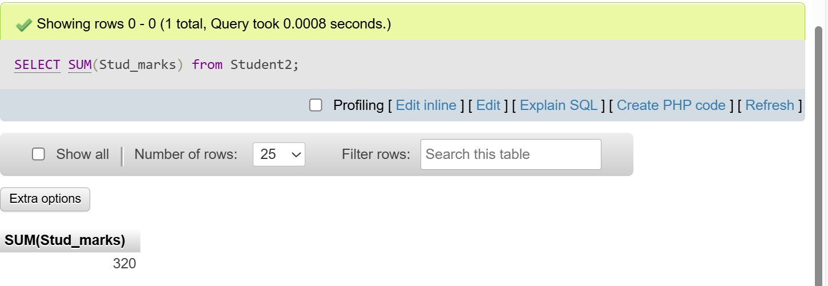

**ii) Count():** Count how many values are present in specified column.



**Output:**

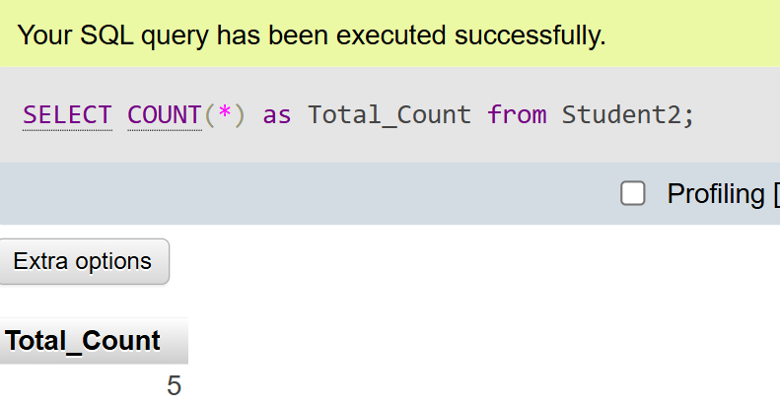

**iii) Avg():** Calculate average of all values from specified column.

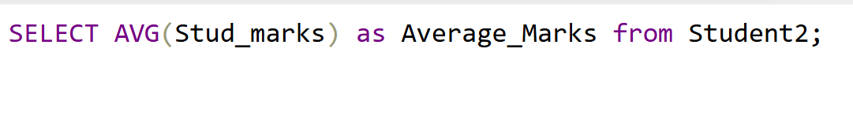

**Output:**

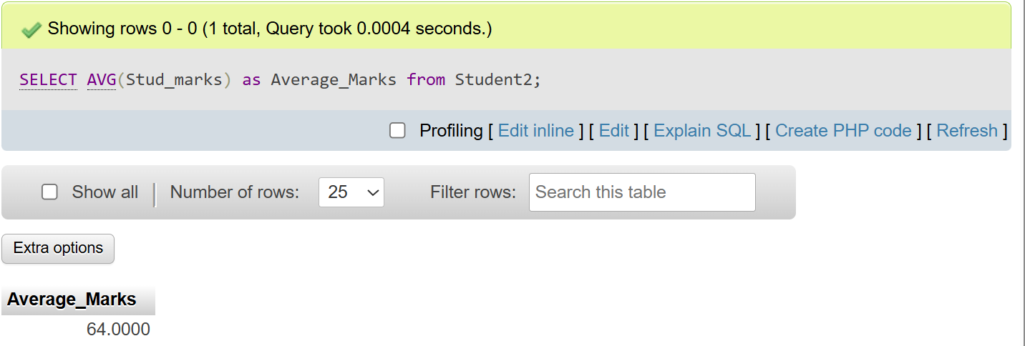

**iv) Min():** Used to find smallest value from the specified column.

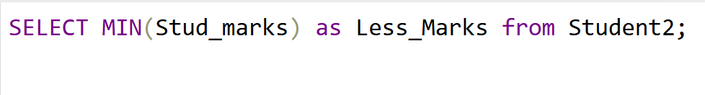

**Output:**

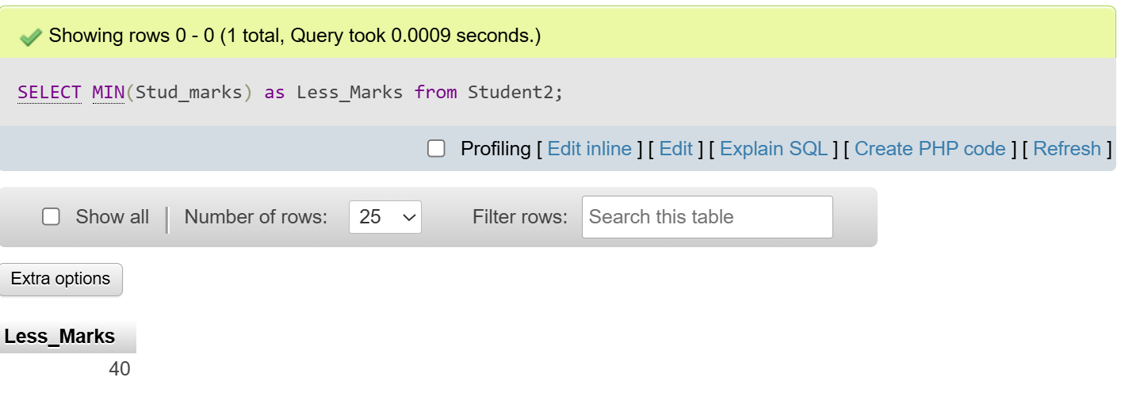

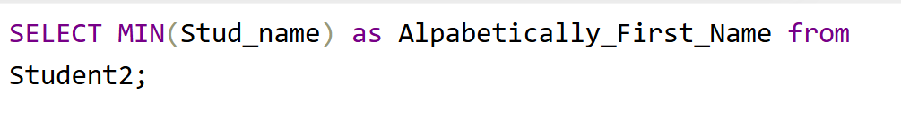**Output:** 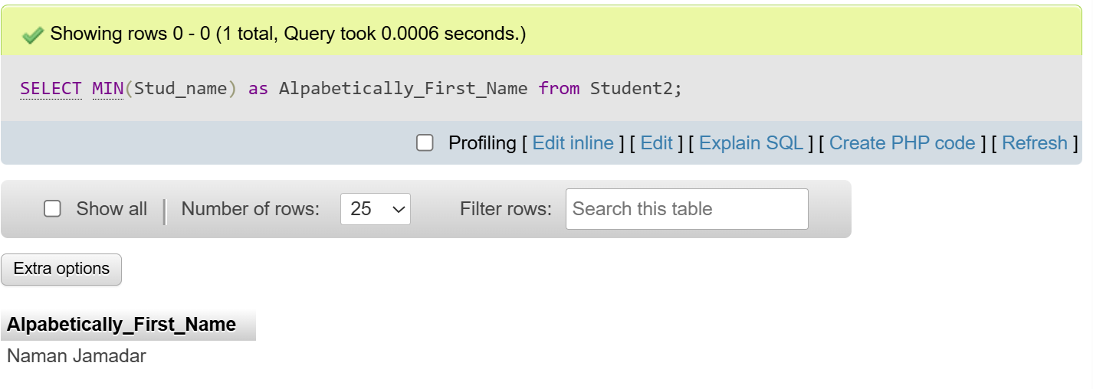

**v) Max():** Used to find largest value from the specified column.

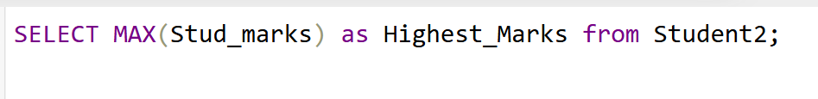

**Output:** 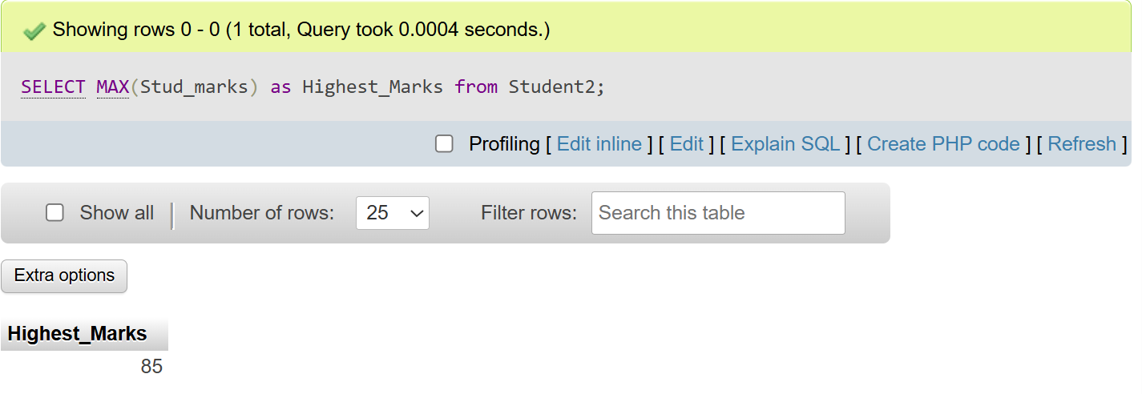

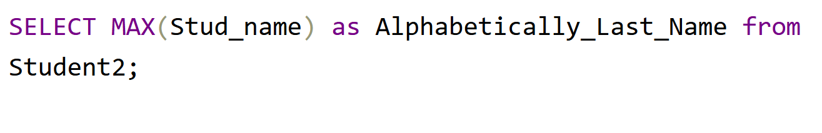

**Output:**

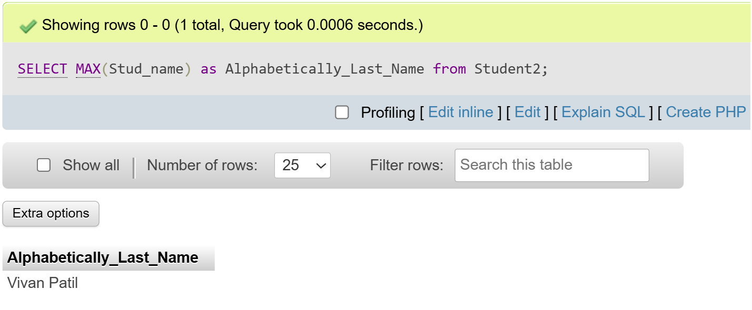

**vii) Round():** Used to round a number to a given number of decimal places.



**Output:**

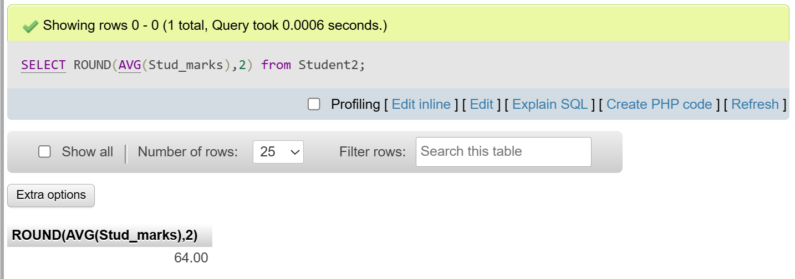

1. 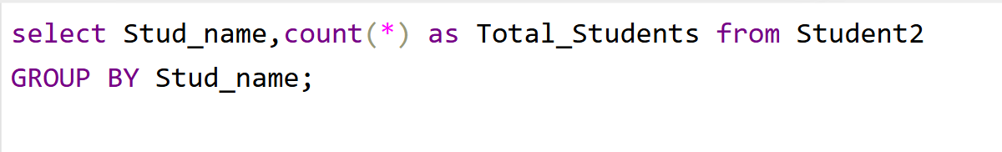**Group By:** The GROUP BY clause groups rows that have the same values into summary rows. It is usually used with aggregate functions (COUNT, SUM, AVG, MIN, MAX) to perform calculations on each group.

**Output:**

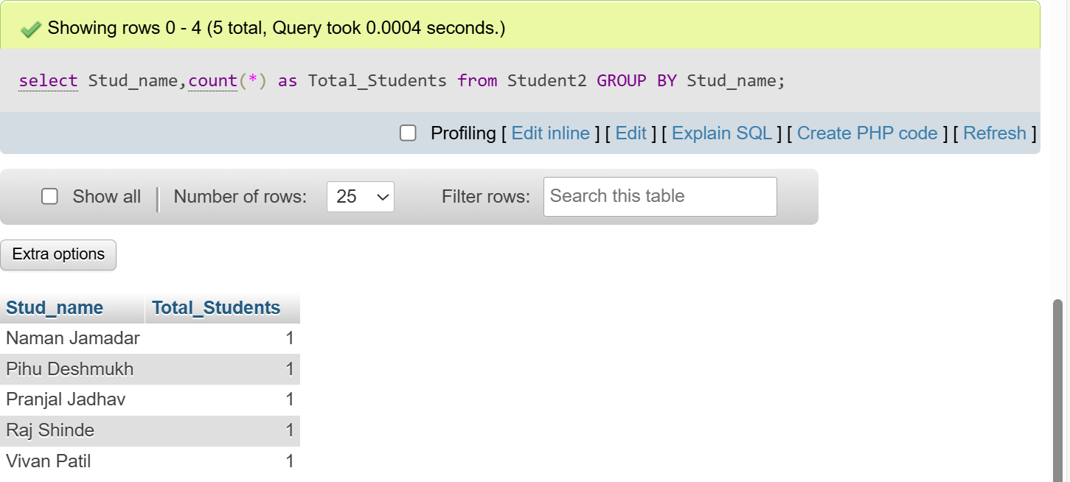

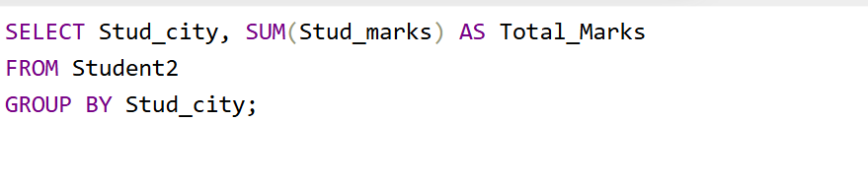

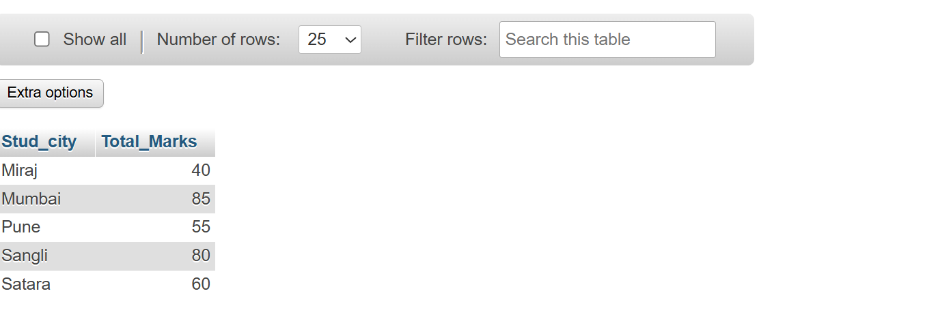**Output:**

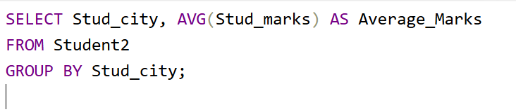

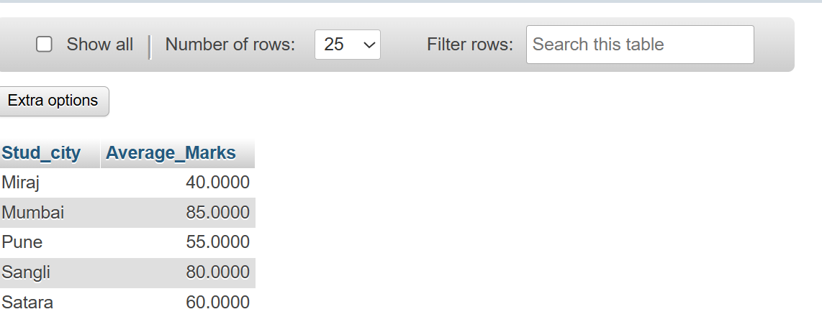**Output:**

1. **Having Clause:**

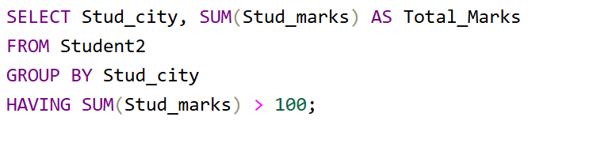

**Output:**

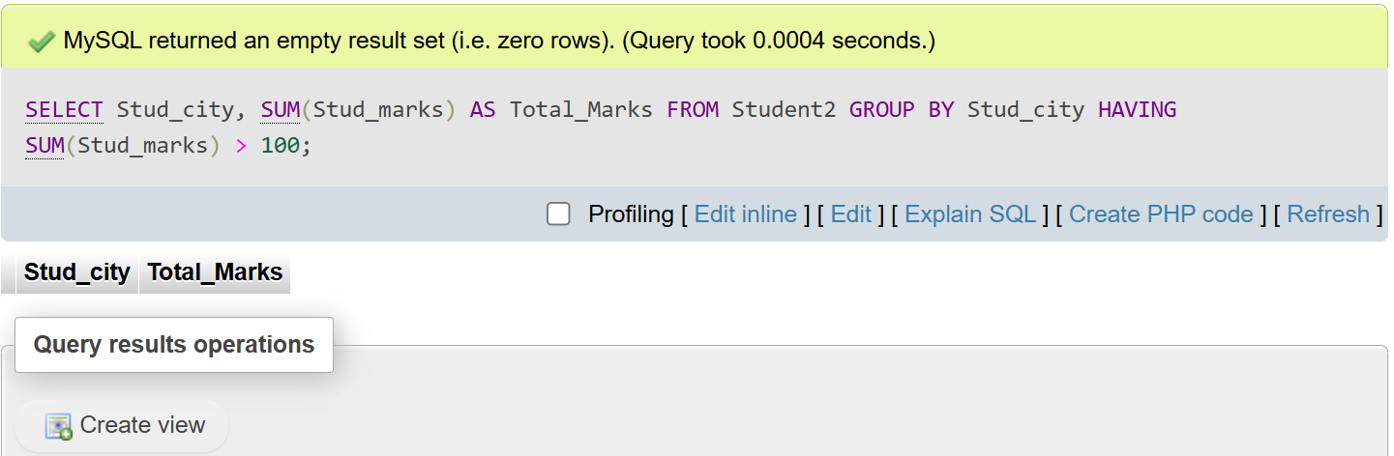

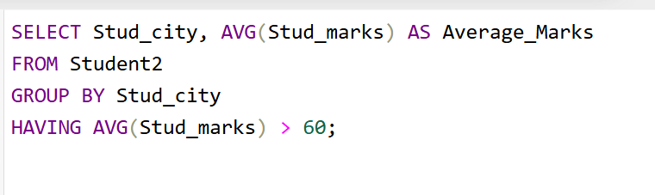

**Output:**

